Another commented workflow :dummy:- this time I'm putting a gnarl into a hypertile  
  
This is not a tutorial and its not entirely well explained ^^  
  
1. As usual, I start from a blank flame.  
Here we go, lets add some waves2 for gnarly shape. For now, I keep the parameters basic just to get the shapes I want and tweak it later.  
  
[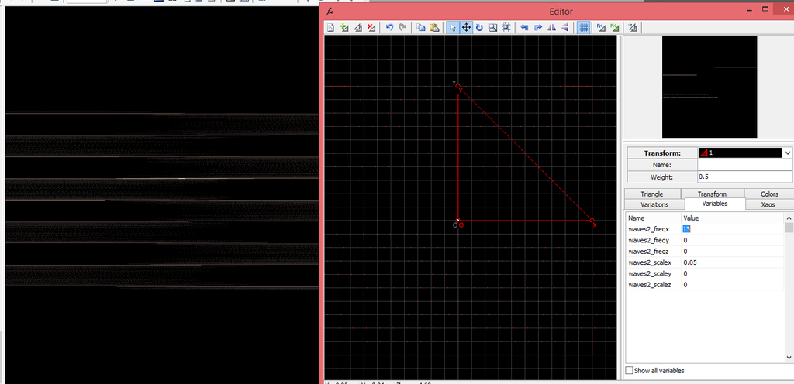](http://sta.sh/025rov2p7qi0)  
  
  
2. My plan is putting it into a p = q = 5 hypertile, so we need a specific radial symmetry to avoid ugly overlaps.  
Ntice it is not exactly perfect, but fine enough to not be visible.  
  
[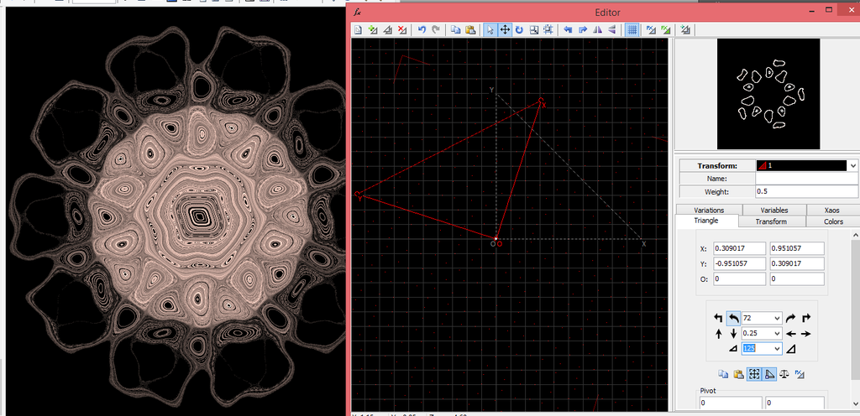](http://sta.sh/0fhx1sqx2mj)  
  
  
3. Time to add some substance with sineblur. Later, I may add more blur and texture transforms, but for now, 1 is good.  
[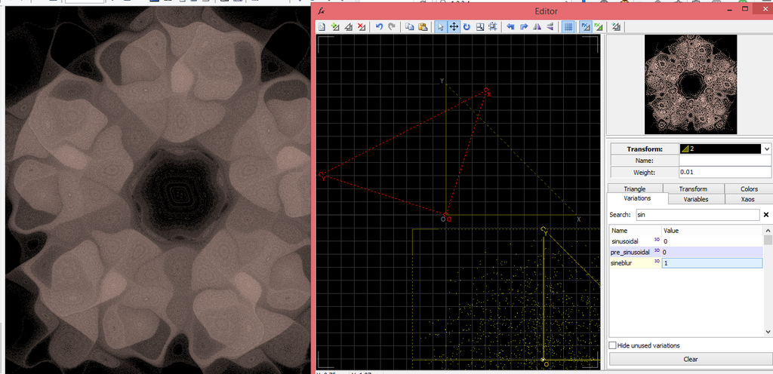](http://sta.sh/0dl2ve7chh3)  
  
  
  
04. A little tweaking just so its less boring =)  
  
[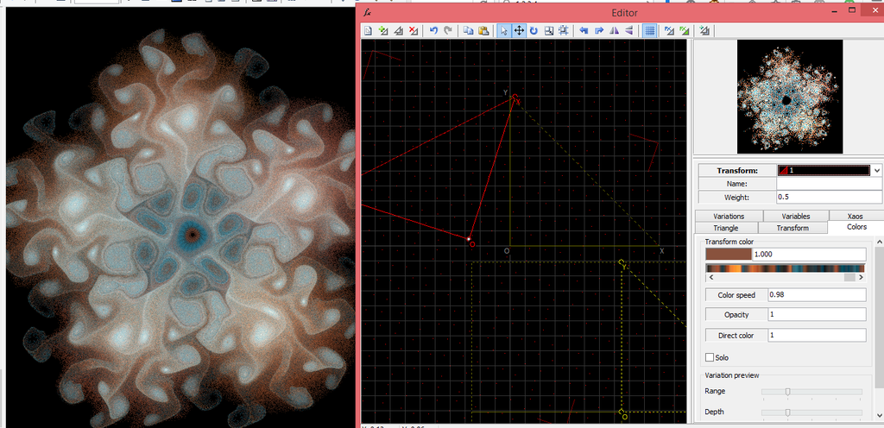](http://sta.sh/0vcbgxe3oaq)  
  
  
5. And once I put it all into a container xform, apo begins to suck. Badly.  
  
[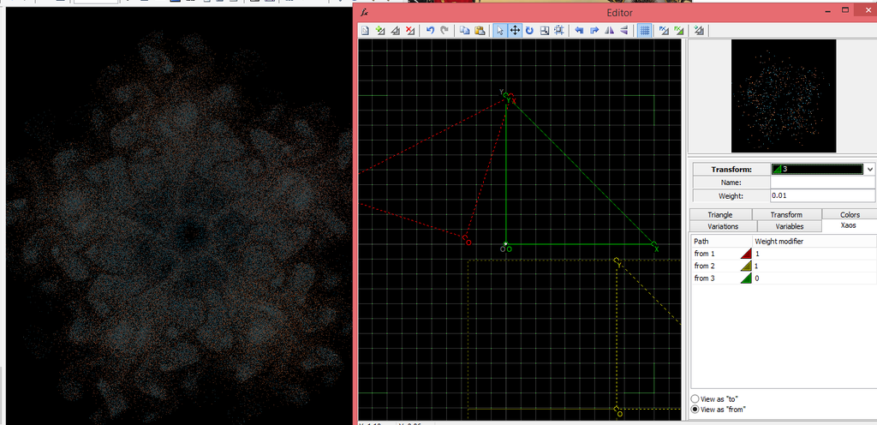](http://sta.sh/02eu2yaqeqnr)  
  
  
6. Hypertile time. Now, I need to untweak it, because I forgot that moving the waves2 transform will shift its center too.  
  
[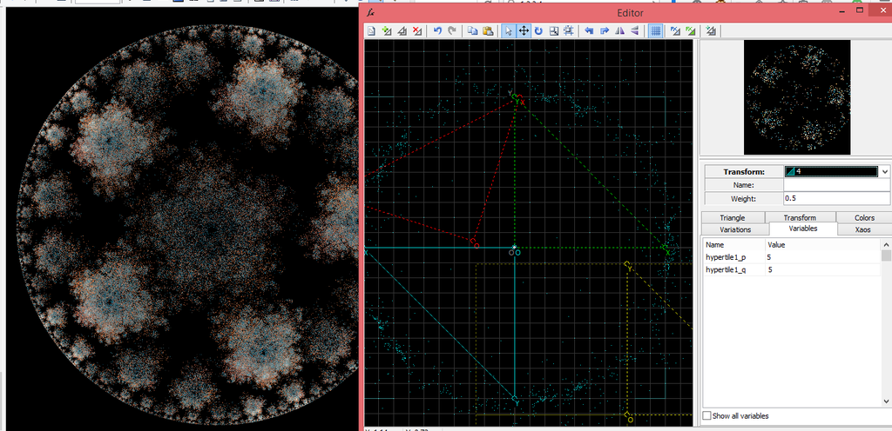](http://sta.sh/0250ez9p40fd)  
  
  
7. At first, I wanted to just move the transform with waves back to origin, but then decided to try to figure it out. In the process, I changed the colors and the shapes so the gnarl looks less messy.  
To get it positioned, I added a ngon transform signaling where it should be, and then moved the container transform around so the keypoints coincide with the gnarl:  
  
[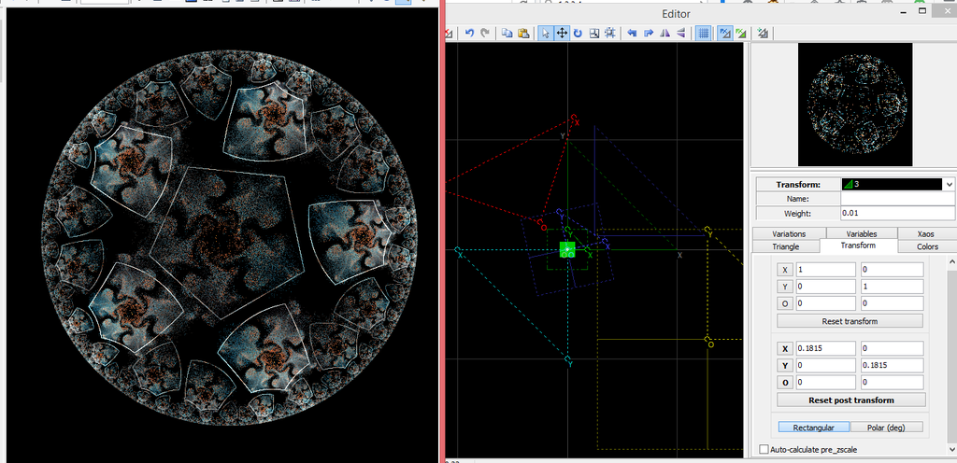](http://sta.sh/029fzwv2p35q)  
[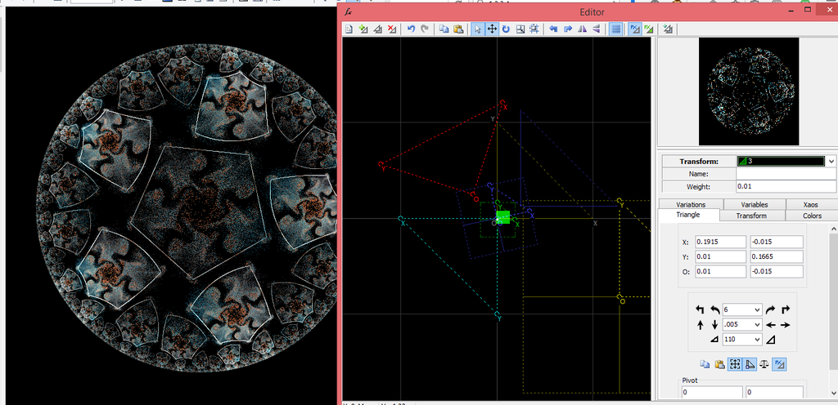](http://sta.sh/08pk7kur0ca)  
  
  
8. Those holes look a bit empty. I decided to just make it bigger, to fill with the same pattern using hypershift.  
  
[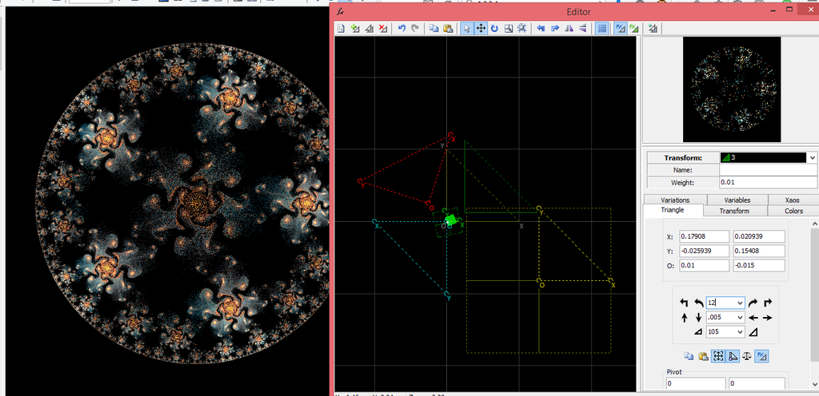](http://sta.sh/0ll7wsidyrv)  
  
  
9. This one is a pain to fit and another thing i just add 0.001 by 0.001, using a blank xform to make it easier to see - because with a blank xform, you only need to watch for those points to coincide (ofc, you need to zoom in to make sure) :dummy:  
  
[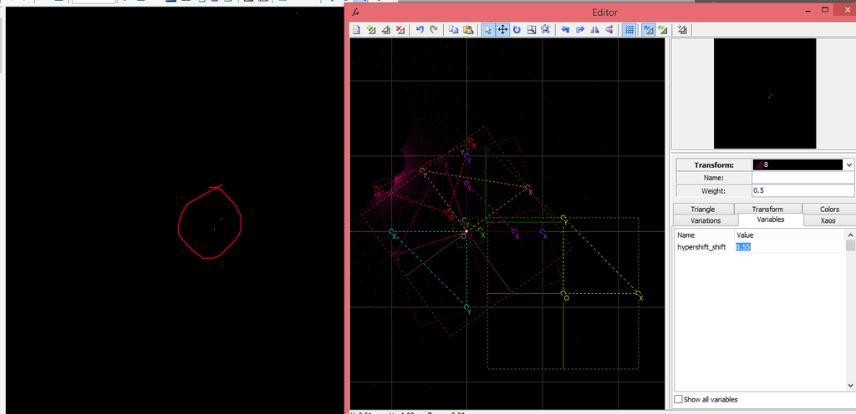](http://sta.sh/0duw9xkwuf2)  
[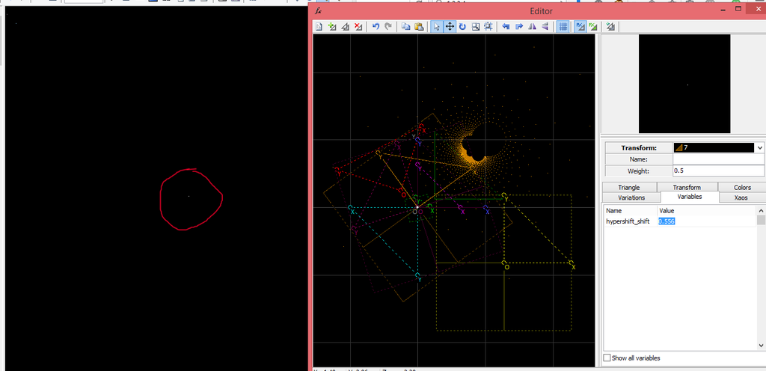](http://sta.sh/0b3s8racdmq)  
  
  
10. After adding the 5 hypershifts (one would fill, but not evenly), I got up to 11 transforms.  
  
[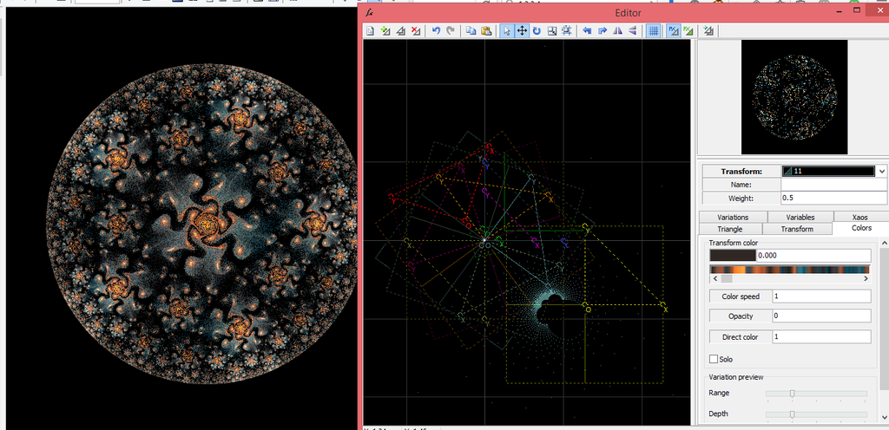](http://sta.sh/019doxzawatd)  
  
  
11. To be honest, I'm quite happy with it already. Except for the empty space around the hypertile.  
So i go back to the hypertile transform and add 2 linked sphericals to it. And then make both visible ;)  
  
[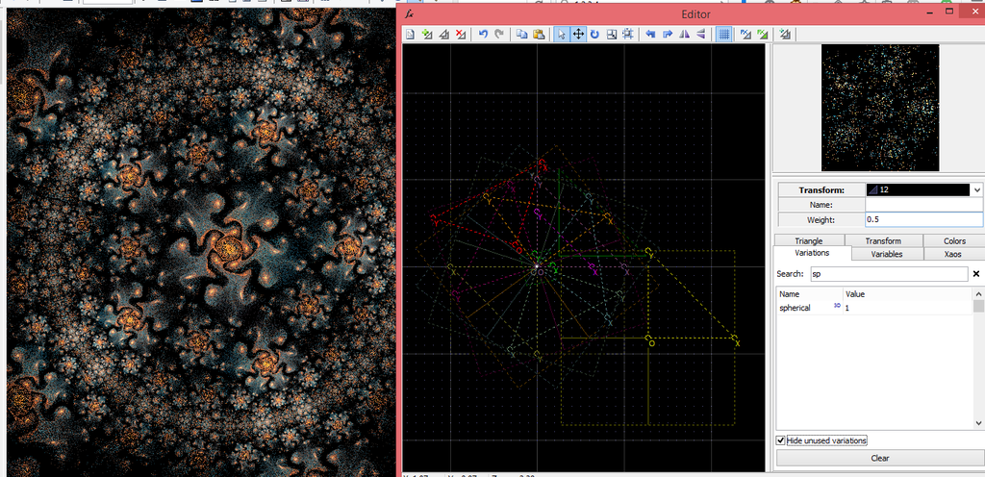](http://sta.sh/0d807gmmrwq)  
  
  
12. Time to switch to Chaotica. With a better preview, I totally see a few things to be changed here =)  
  
[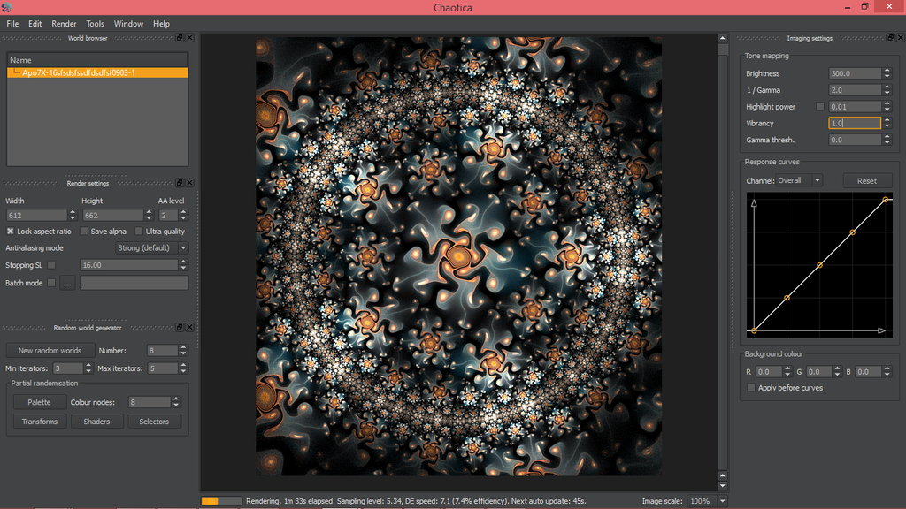](http://sta.sh/01nkrhppjltu)  
  
  
13. And, of course, some curves etc =)Yes, it still overlaps, and it bugs me a lot.  
Also, notice the efficiency. Not even sure if I will render this one.  
  
[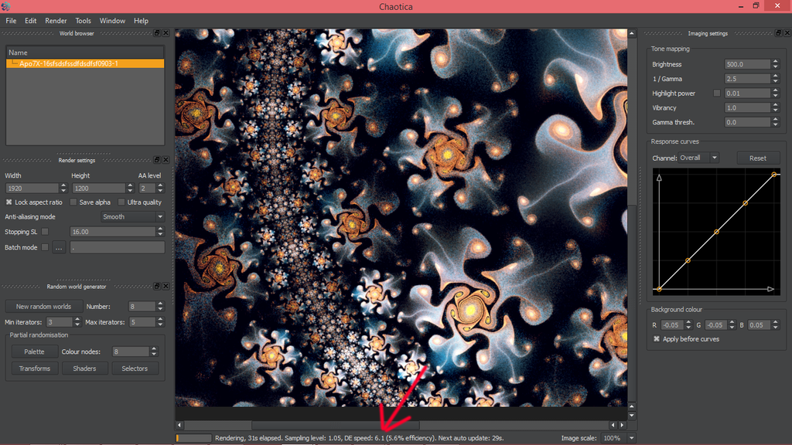](http://sta.sh/03jicmspo8z)